LO2 Activity: RPA Feasibility Case Study — Model Solution
Case Scenario
Global Logistics Corp operates 3 regional distribution hubs and is experiencing high error rates in manual inventory reconciliation.
The company wants to determine which activities should be automated using Robotic Process Automation (RPA).
TASK 1: RPA Feasibility Evaluation
Step 1: Four Candidate Tasks
Assume the company identifies these four processes:
Candidate Task | Current Process | Frequency | Main Problem
A. Inventory Reconciliation | Compare warehouse inventory with ERP records | Daily | Manual comparison and data-entry errors
B. Invoice Data Entry | Transfer supplier invoice information into ERP | Daily | Repetitive data entry
C. Exception Handling | Investigate inventory discrepancies | Daily | Requires human judgement
D. Inventory Report Distribution | Generate and email daily inventory reports | Daily | Repetitive reporting
Step 2: RPA Feasibility Matrix
Use a score from 1–5:
- 1 = Very unsuitable
- 5 = Highly suitable
Criteria:
- Rule-based
- Transaction volume
- Data standardisation
- Error reduction potential
- Implementation simplicity
For complexity, a higher score means easier to implement.
Criteria | A. Inventory Reconciliation | B. Invoice Data Entry | C. Exception Handling | D. Report Distribution
Rule-based | 5 | 5 | 2 | 5
High transaction volume | 5 | 4 | 3 | 5
Standardised data | 4 | 4 | 2 | 5
Error reduction potential | 5 | 5 | 4 | 3
Implementation simplicity | 4 | 4 | 2 | 5
Total | 23/25 | 22/25 | 13/25 | 23/25
Interpretation
A. Inventory Reconciliation — 23/25
Very suitable for RPA because:
- rules are clearly defined
- process occurs frequently
- data comes from structured systems
- manual errors are common
- the same process is repeated every day
B. Invoice Data Entry — 22/25
Also highly suitable because:
- invoices follow relatively standard formats
- employees repeatedly copy information
- data can be validated using predefined rules
- high volume creates significant labour savings
C. Exception Handling — 13/25
Less suitable for full RPA automation.
Why?
An inventory discrepancy might require someone to investigate:
"Why does the system show 100 units but the warehouse has only 92?"
Possible reasons include:
- damaged products
- missing products
- incorrect receiving records
- theft
- incorrect data entry
- returns
This requires human judgement.
RPA could identify and route the exception, but a human should investigate complex cases.
D. Inventory Report Distribution — 23/25
Highly suitable because:
- process is repetitive
- rules are clear
- reports use structured data
- reports are generated regularly
- emails can be automatically distributed
Recommended RPA Opportunities
For this case, the strongest candidates are:
1. Inventory Reconciliation
and
2. Inventory Report Distribution
Invoice Data Entry could also be implemented as another automation opportunity.
Note: The scores are an illustrative teaching model, not an actual assessment of a real company's processes.

TASK 2: ROI Calculation
Let's create realistic financial assumptions.
Current Manual Process
Global Logistics processes approximately:
10,000 inventory reconciliation transactions per month
Each manual reconciliation takes:
6 minutes
Therefore:
10,000 × 6 minutes = 60,000 minutes
60,000 minutes ÷ 60 = 1,000 staff hours/month
Assume the average labour cost is:
$24 per hour
Therefore:
1,000 × $24 = $24,000/month
Current processing cost
$24,000 per month
or
$288,000 per year

After RPA Implementation
Suppose the RPA bot can process a transaction in:
1 minute
10,000 × 1 minute:
= 10,000 minutes
= 166.7 hours
166.7 × $24
= $4,000/month
Therefore:
Manual cost
$24,000/month
Automated cost
$4,000/month
Monthly saving
$24,000 − $4,000 = $20,000
Annual saving
$20,000 × 12 = $240,000

Cost per Transaction
Before RPA
$24,000 ÷ 10,000
= $2.40 per transaction
After RPA
$4,000 ÷ 10,000
= $0.40 per transaction
Cost reduction
$2.40 − $0.40
= $2.00 per transaction
Percentage reduction:
$$\frac{2.40-0.40}{2.40}×100$$
= 83.3% reduction
So the students can conclude:
RPA reduces the estimated processing cost from $2.40 to $0.40 per transaction, representing an approximately 83% reduction in labour processing cost.

ROI Calculation
Assume the company spends:
- RPA software and implementation: $80,000
- Training and testing: $20,000
Total first-year investment:
$100,000
Annual saving:
$240,000
Simple first-year ROI:
$$ROI=\frac{Savings-Investment}{Investment}×100 \\ ROI=\frac{240,000-100,000}{100,000}×100$$
ROI = 140%
Therefore:
The illustrative first-year ROI is 140%.
The simple payback period is:
$$100,000÷20,000=5\text{ months}$$
Payback period ≈ 5 months

TASK 3: Real-Time Inventory Tracking Integration Model
The company operates three regional distribution hubs.
The recommended architecture is:
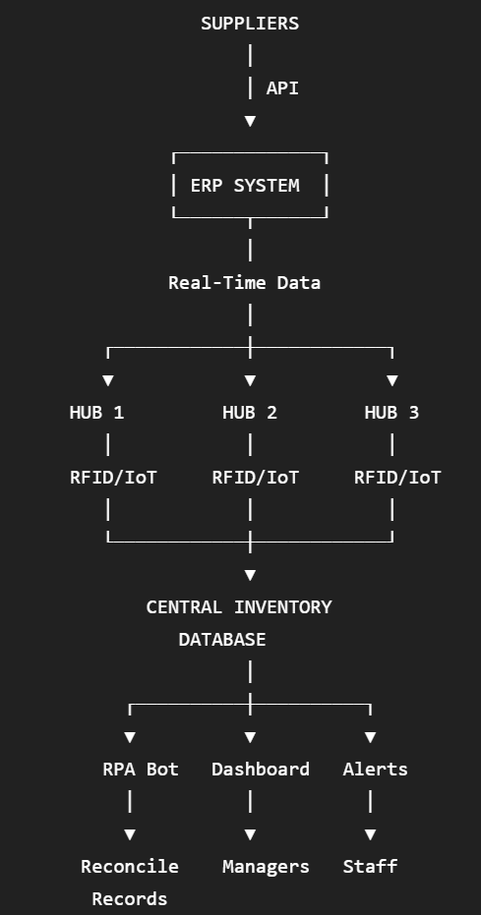

How the System Works
Step 1 — Product arrives
Products arrive at one of the three distribution hubs.
Example:
Hub 1 receives 500 wireless keyboards.
RFID scanners automatically identify the products.
Step 2 — Inventory is updated
The RFID system sends information to the inventory system.
Instead of:
Employee manually enters 500 units
the system automatically records:
Wireless Keyboard: +500

Step 3 — Real-Time Monitoring
Managers can see:
Hub | Product | Stock
Hub 1 | Wireless Keyboard | 500
Hub 2 | Wireless Keyboard | 280
Hub 3 | Wireless Keyboard | 150
The company therefore has a central view of inventory.

Step 4 — RPA Reconciliation
The RPA bot compares:
Physical/RFID Inventory
against
ERP Inventory

Example:
Product | RFID Count | ERP Count | Difference
Keyboard | 500 | 500 | 0
Mouse | 300 | 295 | 5
Monitor | 120 | 120 | 0
Laptop | 80 | 75 | 5
The RPA bot automatically identifies:
⚠️ Mouse discrepancy: 5 units
⚠️ Laptop discrepancy: 5 units

Step 5 — Exception Handling
This is where humans become important.
The RPA bot should not automatically decide why the discrepancy occurred.
Instead:
RPA detects discrepancy
↓
Creates exception ticket
↓
Warehouse staff investigates
↓
Possible reasons:
- damaged goods
- missing stock
- incorrect receiving
- incorrect shipment
- returned goods not recorded
- data-entry error
↓
Staff corrects the record
↓
RPA updates reconciliation status

Step 6 — Automatic Alerts
The system can also establish rules.
For example:
If inventory falls below 50 units → Send alert.
If stock reaches:
45 units
the system automatically sends:
⚠️ LOW INVENTORY: Wireless Keyboard – Hub 1 – 45 units remaining.
The company can then initiate replenishment.

